AN EFFICIENT SYSTEM TO DETECT AND BLOCK THE UNAUTHORIZED USAGE OF MOBILE PHONES IN RESTRICTED AREAS
Dr.R.Sabitha¹, Ms. Shriya Raviprasad², Ms.R.Rajeshwari³, Ms. V. Alamelu⁴
¹Professor and Head, Department of Information Technology, Jeppiaar Engineering College,
Chennai, Tamil Nadu. sabitha_ramadoss@yahoo.com
^{2, 3, 4} Final years B.Tech Students, Department of Information Technology, Jeppiaar Engineering College,
Chennai, Tamil Nadu. shriyaa.prasad@gmail.com, rajeshwari16.ram@gmail.com, alamelu.valliapan@gmail.com

Abstract-- The main objective of our project is to design a “Nova Intelligent Device”, which classifies the authorized and unauthorized numbers in a particular area and allows communication establishment to only the authorized numbers and blocks all unauthorized users. The key feature in this device is that, we are using a jammer, which will block all the signals from or to any base station to a mobile phone. Here, we make use of two Nova intelligent devices, where one is inside the jammed area, named as device1 and another is outside the jammed area, named as device2. Another point to be noted here is that, there is already a separate channel allocated between our device2 and the base stations of different service providers in that area, with prior authorization from the respective service providers. For any incoming call to a person in the restricted area, the call would be first directed to our Device2 via the separate channel assigned. Then the Device2 would forward the call to Device1 which is inside the jammed area. For any outgoing call, the call would be first directed to our device1 and then to the device2 and then to the respective base station if in case the call is made by an authorized person.
I. INTRODUCTION

Mobile phone usage has become indispensable in today’s scenario. But people are making use of it even in restricted areas such as schools, colleges, factories etc. In such a situation, one might think of using a cell phone jammer to block its usage. But in this case, even if a person wants to make an important call, he would not be able to. Hence, we have come out with a solution to overcome this problem.
In this case when a call is made, it is forwarded to our “Nova Intelligent Device”, which is already fed with a list of authorized numbers. This device will check if the call is made from an authorized user. If the call is made from an authorized user, then the call will be forwarded to the respective base station and then the communication would be established. If the call is from a foreign number then the call will be denied. Same way, for an incoming call, the signal from the base station is directed to our device, which will check if it’s for authorized person and establish communication if yes.
The major advantage of our project is that, a person will be allowed to carry mobile phone, but only in the restricted area he will be denied the service if he/she is unauthorized. When the person moves out of the area, he/she would be able to use the phone as normally as before.

II.EXISTING SYSTEM

There are many related systems which are being developed for the mobile phone usage, detection and restriction. One such device is a novel mobile detector which detects the presence of GSM signal and indicates it. Here, when any mobile is used in the prohibited place, this Device will detect that mobile signal through the antenna. In that particular place, when a mobile signal is received, the receiver in this device will receive the signal through the antenna. When mobile receive the signal at the particular place, the alarm makes the sound for indication of the mobile and one LED will glow for the indication. Then with this device GSM Module is attached to send the Short Message service (SMS) to the registered number in the microcontroller. This detector is used to detect the presence of mobile. When it detects any mobile, it gives a signal to the PIC16F877A microcontroller. The controller when receives this signal will turn ON the buzzer circuit and will also send the detected message to some particular mobile numbers via the GSM module. Also the information is displayed in the LCD module as “MOBILE DETECTED”[1].

The Jammer is another device which deals with blocking of mobile usage irrespective of the user. Mobile phone jammers are radio communications transmitters designed to interfere with licensed services operated by mobile carriers. A mobile phone works by communicating with its service network via a base station. A mobile phone jammer typically works by preventing the mobile phone from receiving signals from base stations. As a result, the mobile phone does not attempt to transmit to a base station, even though it may be within range. A cell phone jammer emits signals in the same frequency range that cell phones use, effectively blocking their transmissions by creating strong interference. Someone using a cell phone within the range of a jammer will lose signal, but have no way of knowing a jammer was the reason. The phone will simply indicate poor reception strength as in [4], [5], [8]. The major disadvantage here is that mobile usage will be completely blocked and a person will not be able to make a call during the emergency situation.

III.PROPOSED SYSTEM
Our system aims at detecting and selectively blocking the usage of cell phones in restricted areas. The various works related to cell phone usage restriction restricts the usage completely irrespective of the user. But our system makes use of a special nova intelligent device in which the authorized numbers are stored. So, when a call is made in the restricted area, the call will be directed to our device, which then checks whether the number is authorized, if in case the number is authorized then the call will be directed to the respective base station through the separate channel allocated between the device and the corresponding base station. When the detected number is found to be unauthorized the call will not be directed to the base station and hence the call is blocked. Thus, with the help of our system the authorized users can make a call or receive a call without any interruption and the unauthorized users will be denied the access.

- PROPOSED METHODOLOGY
Our methodology consists of the following steps.
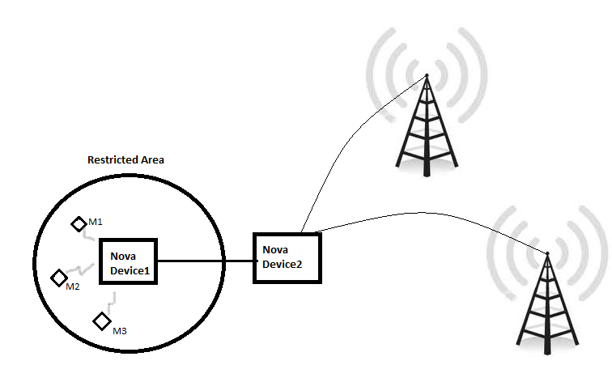
Figure.1: Architecture diagram
1) Jam the restricted area: A jammer which emits frequency signals ranging 800-1900MHZ frequency is placed in the restricted area as shown in fig.1. Jammer should be designed according to total number of meters that has to be blocked. Base station also emits frequency in the range 800-1900MHZ. Hence, these signals will get interfered with the signals coming from any base station. Thus, there would be no signal reaching the mobile.
2) Initiate the Nova device1: This device is placed inside the jammed area. It acts like a miniature base station. The transceiver in the base station sends signals with frequency 200-250MHZ [7]. One point to be noted here is that, the frequency has to be purchased from the Federal Communication Commission (FCC).Other than the usual parts contained in the base station like Power Amplifier, Combiner, Duplexer, Antenna, etc., it contains a special circuitry with EEPROM and a processor.
The Electrically Erasable Programmable read only memory (EEPROM) is fed with a list of authorized numbers. Any signal reaching this device, will be first processed by the CPU and then it’s checked, whether the call is to/from an authorized number. If authorized, then communication will take place. Else, it’s denied.
3) Attach Frequency Mixer to every authorized handset: Since, when a call option is pressed in the mobile, the mobile sends a signal in the range 900-1800MHZ frequency according to the SIM module embedded in the Mobile Phone. But, for the authorized numbers to use the 200-250MHZ frequency available in that jammed area, a frequency mixer is made use of. Here, when a call is made from an authorized phone, the signals generated are in the frequency 200-250MHZ. It’s also designed to receive call in the same range as in [3].
4) Initiate the Nova Device2: This device is placed outside the jammed area. Device1 is connected with Device2 via a separate communication channel with a different frequency, say 500MHZ. All the communication from the Device1 will always be first forwarded to Device2. Device2 has separate communication channel links with different Base stations of various Service providers in that area. This channel can be with the usual frequency used by the Base Stations.
Hence, for any incoming call/message, to a person in the restricted area, it will be via Device2 and then to Device1. If it’s for an authorized number, then the communication is established. For an outgoing call in the restricted area, it will be via Device1. If it’s from an authorized number, it will be forwarded to Device2 and from there to the Base station. Communication will thus be established.

- EXPERIMENTAL RESULTS
We have simulated our idea using Network Simulator (ns2). A network simulator is a technique of implementing a network on a computer. Ns2 is a discrete event simulator targeted at network research. The discrete event simulator models the operation of a system as a discrete sequence of events in time. Each event occurs at a particular instant of time and marks a change of state in system as in [9]-[11].
In our simulation model, we have created sample nodes for mobile phones, our devices and the base stations. Every time when a mobile phone node tries to communicate, our device1 checks whether it’s authorized by using the values stored in a file. The file consists of the names of the authorized nodes. In order to differentiate the authorized and unauthorized nodes, we have given green color and red color respectively. In order to classify the Base stations and the devices we have given color and size differentiation. We have also given a color change for a Mobile Phone node moving out of the jammed area. Any Mobile Phone node in the restricted area, wishing to communicate with any other Mobile phone node, will be able to communicate only if it’s authorized and only via our Device1. Our Device1 checks with the file containing the list of authorized numbers and then forwards the communication to Device2 and then to the Base station.
The following are the screen shots of our simulation. The first screen shot shows the communication between our two devices. The second screen shot is the final result after all nodes have communicated.
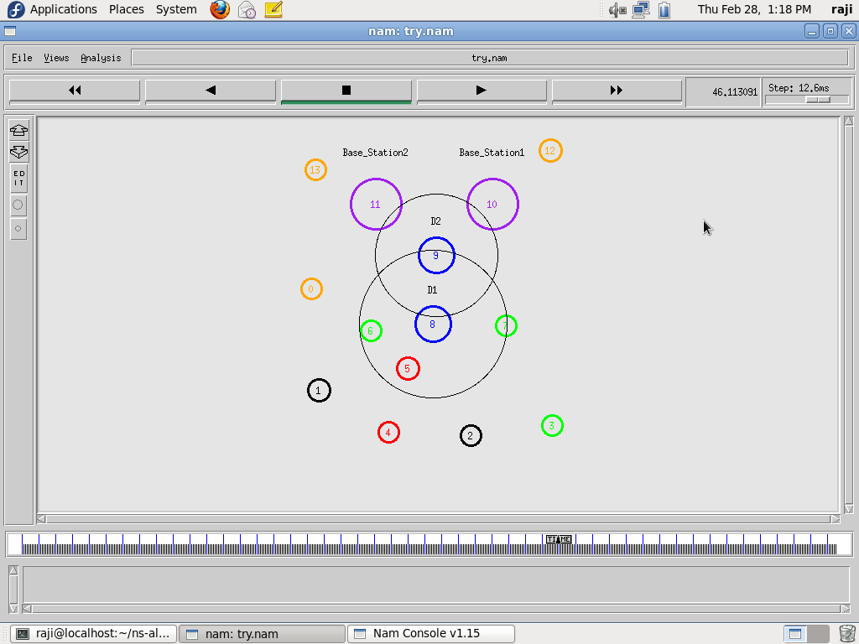
Figure.3.During Communication between Device1 and Device2.
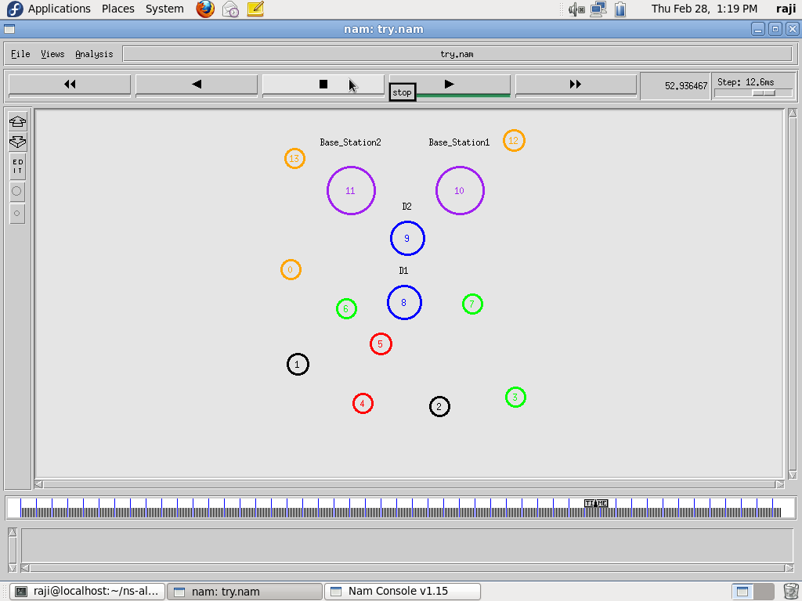
Figure.4. After communication between several nodes.

- ADVANTAGES OF OUR SYSTEM
The main advantage of our system, when compared to the present existing systems is that our device detects the mobile usage and also blocks the foreign numbers and allows the authorized users to communicate without any hindrance. Whereas, the existing system does only detection of mobile usage and it does not block them. Certain systems completely block the mobile usage. Since our system does mobile detection along with selective blocking it proves to be very much efficient and useful when compared to the existing systems. One more advantage here is that, at a particular time, many authorized users can communicate simultaneously.

IV. CONCLUSIONS
In today’s scenario mobile phones are very much essential. If we consider the case of colleges, the students should not use the mobile phones inside the college. We can use a metal detector to detect the mobile phones and stop the students from bringing it. But they need it when they go out of the college. Hence our device will prove to be useful in this case because it will allow them to bring the mobile phones and stop them from using it in restricted areas. Hence our system can also be extended to various other restricted areas like factories, hospitals and other places where such need exists. Thereby we conclude that our system will prove to be very efficient to prevent the illegal usage of mobile phones.

REFERENCES
[1] Paper on Novel Mobile Detector Sensing Alarming and Reporting System, by K. Mohan Dece.
[2] Jochen Schiller, “Mobile Communications” Second Edition, Pearson Education, 2003.
[3] http://www.radio-electronics.com/info/rf-technology-design/mixers/rf-mixers-mixing-basics-tutorial.php
[4] http://electronics.howstuffworks.com/cell-phone-jammer2.htm
[5] http://electronics.howstuffworks.com/cell-phone-jammer.htm
[6] http://273k.net/gsm/find-a-gsm-base-station-manually-using-a-usrp/
[7] http://www.ehow.com/how_7822111_buy-fcc-frequency.html
[8] Review of the Mobile Phone Jammer Prohibition, Public Discussion Paper, January 2010, Published by the Australian Communications and Media Authority.
[9] The ns Manual (formerly ns Notes and Documentation), The VINT Project A Collaboration between researchers at UC Berkeley, LBL, USC/ISI, and Xerox PARC. Kevin Fall hkfall@ee.lbl.govi, Editor Kannan Varadhan, hkannan@catarina.usc.edui, Editor July 25, 2008.
[10] An Introduction to NS, Nam and OTcl scripting, Paul Meeneghan and Declan Delaney, NUIM-CS-TR-2004-05.
[11] Mark Gresis's Tutorial for the UCB/LBNL/VINT Network Simulator "ns”, http://www.isi.edu/nsnam/ns/tutorial/index.html

